Ultrasonic-Activated Irrigants for Endodontic Smear Layer Removal: A Systematic Review and Meta-analysis
Article type: Systematic Review and Meta-analysis
ABSTRACT
Background: The smear layer produced during root canal preparation may obstruct dentinal tubules and limit the penetration of irrigants, intracanal medicaments, and sealers.
Purpose: This systematic review and meta-analysis evaluated the comparative effectiveness of ultrasonic-activated irrigants for smear layer removal in endodontic treatment.
Materials and Method: PubMed/MEDLINE, Scopus, and Web of Science were searched for peer-reviewed studies published from 2017 onward. Eligible studies used human permanent teeth or root canal specimens, compared passive or ultrasonic-activated irrigation with conventional irrigation or other activation systems, and reported smear layer outcomes assessed by scanning electron microscopy or field-emission scanning electron microscopy. Effect estimates were pooled on the log odds ratio scale using extracted or convertible quantitative data.
Results: A total of 228 records were identified. After duplicate removal, screening, and full-text eligibility assessment, 12 in vitro or ex vivo studies were included. Most studies favored irrigant activation over manual syringe irrigation, although the superiority of passive ultrasonic irrigation varied when compared with sonic, negative-pressure, laser, or mechanical activation systems. The pooled log odds ratio was 1.28 (95% CI, 0.68-1.89; p<0.001), corresponding to an odds ratio of 3.60 (95% CI, 1.97-6.62). Heterogeneity was low to moderate (I²=32.38%; Q=15.43; p=0.164).
Conclusion: Ultrasonic-activated irrigation improves smear layer removal under laboratory conditions, but its effectiveness depends on irrigant type, activation protocol, comparator technique, canal morphology, and assessment site. Clinical extrapolation should be cautious because all included studies were laboratory-based.
Key words: Endodontics; Root Canal Irrigants; Ultrasonics; Smear Layer; Meta-Analysis.

INTRODUCTION
Endodontic treatment aims to preserve teeth by shaping, cleaning, disinfecting, and obturating the root canal system. Mechanical preparation produces a smear layer composed of dentin debris, pulp remnants, microorganisms, and organic and inorganic components. This layer may occlude dentinal tubules, interfere with irrigant and intracanal medicament penetration, and compromise sealer adaptation during obturation [2,3].
Root canal disinfection cannot rely on instrumentation alone because canal anatomy often includes narrow, oval, curved, or inaccessible areas. Substantial canal wall surfaces may remain untouched after mechanical preparation, especially in the apical third and in anatomical irregularities such as isthmuses and fins. Therefore, irrigation protocols are central to removing debris and smear layer from areas that instruments cannot adequately contact [4,5].
Sodium hypochlorite (NaOCl) and ethylenediaminetetraacetic acid (EDTA) remain widely used because they perform complementary functions. NaOCl provides tissue-dissolving and antimicrobial effects, whereas EDTA acts as a chelating agent against the inorganic component of the smear layer. However, conventional syringe irrigation often has limited fluid exchange and penetration, particularly near the apical area [2,3,19,20].
Passive ultrasonic irrigation (PUI) and other forms of ultrasonic-activated irrigation have been introduced to improve the movement of irrigants inside the canal. Ultrasonic activation can generate acoustic streaming and cavitation-related fluid movement that increases the contact between irrigant and dentin surface. Experimental studies have reported that PUI or ultrasonic-activated irrigation can improve canal cleanliness compared with syringe irrigation, although findings vary according to irrigant, canal anatomy, activation time, observation level, and comparator system [4-17,21,24].
Previous reviews have compared sonic versus ultrasonic activation, EDDY versus ultrasonic activation, or laser-activated irrigation versus ultrasonic activation [4,5,18]. However, a focused synthesis on ultrasonic-activated irrigants for smear layer removal remains clinically and methodologically relevant because available primary studies use different irrigants, scoring systems, canal levels, and comparator techniques. This systematic review and meta-analysis aimed to evaluate the comparative effectiveness of ultrasonic-activated irrigants on smear layer removal in endodontic treatment and to interpret the evidence in relation to irrigant type, comparator technique, SEM/FESEM assessment, and heterogeneity across laboratory studies.

MATERIALS AND METHOD
Design and reporting standard
This study was designed as a systematic review and meta-analysis of laboratory-based endodontic studies. Reporting followed the Preferred Reporting Items for Systematic Reviews and Meta-Analyses (PRISMA) 2020 statement [1]. The review question was structured using the PICO framework shown in Table 1.
Search strategy
The literature search was conducted in PubMed/MEDLINE, Scopus, and Web of Science for peer-reviewed articles published from January 2017 onward. Search terms combined controlled and free-text terminology related to passive ultrasonic irrigation, ultrasonic activation, endodontics, root canal dentin, smear layer removal, irrigants, EDTA, NaOCl, QMix, SEM, FESEM, and quantitative effect data. The search strategy and number of records retrieved from each database are summarized in Table 2.
Eligibility criteria
Studies were eligible when they met the following criteria: primary quantitative in vitro or ex vivo design; use of human permanent teeth, root canal dentin, or relevant endodontic specimens; evaluation of smear layer removal after ultrasonic-activated or passive ultrasonic irrigation; use of a comparator such as conventional syringe irrigation or another non-ultrasonic activation system; smear layer assessment using SEM or FESEM; and reporting of odds ratio, p-value, confidence interval, or extractable raw data that could be converted into dichotomous effectiveness categories. Reviews, narrative reviews, systematic reviews, meta-analyses, editorials, letters, case reports, protocols, and studies without extractable smear layer data were excluded.
Study selection and data extraction
Records identified from the three databases were screened after duplicate removal. Titles and abstracts were examined first, followed by full-text eligibility assessment. Data were extracted into a spreadsheet and included author, year, study design, sample type, irrigation technique, comparator group, root canal evaluation level, SEM/FESEM scoring system, effective and ineffective cleaning categories, p-value, confidence interval, and effect size. The study selection process is shown in Figure 1.
Outcome definition and effect measure
Smear layer scores reported by individual studies were transformed into dichotomous categories to permit quantitative synthesis. Low smear layer scores indicating open dentinal tubules or clean dentin surfaces were classified as effective cleaning, whereas moderate to severe smear layer coverage was classified as ineffective cleaning. Because different studies used different ordinal scoring systems, the dichotomization threshold was based on each study’s definition of clean or minimally covered dentin surfaces. Extracted data were analyzed as log odds ratios. For clinical interpretability, the pooled log odds ratio was also back-transformed into an odds ratio.
Risk-of-bias and evidence appraisal
The methodological appraisal focused on domains relevant to laboratory endodontic studies: clarity of specimen selection, standardization of root length and canal preparation, allocation to intervention groups, description of irrigant concentration and activation protocol, SEM/FESEM scoring method, examiner calibration or blinding, completeness of outcome data, and appropriateness of statistical analysis. Because all included studies were in vitro or ex vivo studies, the level of evidence was interpreted as laboratory evidence rather than direct clinical evidence.
Statistical analysis
The quantitative synthesis was conducted using log odds ratio as the main effect measure. Heterogeneity was assessed using Cochran’s Q statistic and I². A p-value lower than 0.05 was considered statistically significant. A funnel plot was used to visually assess asymmetry and potential small-study effects. Because comparator techniques varied across studies, pooled findings were interpreted as comparative laboratory evidence rather than as a direct clinical recommendation.

RESULTS
Study selection
The initial search identified 228 records: 64 from PubMed/MEDLINE, 91 from Scopus, and 73 from Web of Science. After removal of five duplicates, 223 records were screened by title and abstract. A total of 165 records were excluded at this stage. Fifty-eight full-text articles were assessed for eligibility, and 46 were excluded for reasons including absence of convertible quantitative data, lack of an appropriate comparison group, unclear smear layer outcome, unsuitable specimens, unsuitable design, or insufficient extraction data. Twelve studies were included in the qualitative synthesis and meta-analysis (Figure 1).
Characteristics of included studies
The 12 included studies were published between 2017 and 2024. All used in vitro or ex vivo experimental designs. SEM was used in 10 studies and FESEM in two studies. All studies assessed passive or ultrasonic-activated irrigation, while comparators included conventional syringe irrigation, sonic or mechanical activation, EndoActivator, EDDY, EndoVac, XP-Endo Finisher, continuous ultrasonic irrigation, and laser-activated irrigation. The frequency distribution of included study characteristics is presented in Table 3, and the summary of individual study findings is presented in Table 4.
Meta-analysis
The forest plot showed a positive pooled effect for ultrasonic-activated irrigants on smear layer removal. The pooled effect estimate was 1.28 on the log odds ratio scale (95% CI, 0.68-1.89; p<0.001), which corresponds to an odds ratio of 3.60 (95% CI, 1.97-6.62). This indicates that effective smear layer removal was more likely in groups receiving ultrasonic-activated irrigation or comparable activated protocols than in conventional or less effective comparator groups. Heterogeneity was low to moderate and not statistically significant (Q[11]=15.43; p=0.164; I²=32.38%) (Figure 2).
Individual study direction
Several studies demonstrated individually significant positive effects, including Prado et al. [7], Miguens-Vila et al. [14], Al-rujaib et al. [15], and Wigler et al. [16]. Other studies showed positive directions but wider confidence intervals crossing the null value on the log odds ratio scale. Machado et al. [12] and Mancini et al. [13] showed negative point estimates, suggesting that under some experimental designs, comparator technologies such as sonic, mechanical, or laser activation may perform as well as or better than PUI. These findings indicate that the effectiveness of PUI is context-dependent rather than absolute.
Funnel plot
The funnel plot showed an asymmetrical distribution, with most studies positioned on the positive side of the pooled effect and a small number of negative or less favorable estimates. This pattern suggests possible small-study effects, methodological variability, or selective publication of positive laboratory findings. However, visual interpretation should be cautious because the meta-analysis included only 12 studies (Figure 3).
DISCUSSION
This systematic review and meta-analysis found that ultrasonic-activated irrigants improved smear layer removal under laboratory conditions. The pooled estimate favored activated irrigation, and heterogeneity was low to moderate. This supports the concept that irrigant activation is an important adjunct to mechanical preparation because conventional syringe irrigation may not provide adequate irrigant exchange in anatomically complex or apical regions [6-21].
The biological and mechanical rationale for the observed effect is consistent with the proposed action of ultrasonic activation. By increasing fluid movement inside the root canal, PUI can enhance irrigant renewal, facilitate contact with dentin surfaces, and support dislodgment of the smear layer. Nevertheless, NaOCl alone cannot adequately remove the inorganic smear layer, and chelating solutions such as EDTA are still required for effective smear layer removal [2,3,20,24]. Therefore, the effectiveness of ultrasonic activation should be interpreted together with the irrigant sequence used in each primary study.
The included studies did not uniformly show that PUI was superior to all comparator techniques. Some studies reported stronger performance for EDDY, EndoVac, EndoActivator, continuous ultrasonic irrigation, dual-action irrigants, intracanal heating, or laser-assisted protocols in specific canal thirds or experimental conditions [9,12-15,18,22,23,25,26]. This is clinically important because it indicates that the question is not simply whether irrigation is activated, but how activation is delivered, which irrigant is used, how long activation is performed, and which area of the canal is evaluated.
The apical third remains the most challenging region for smear layer removal. Studies assessing multiple canal levels frequently reported incomplete cleaning in the apical area, even when activation systems were used [6,9,10,14,16,17,19,20]. This limitation may be explained by reduced canal diameter, vapor-lock effects, anatomical irregularities, and limited tip movement or irrigant exchange near the working length.
The present review also has methodological implications. Pooling smear layer data required transformation of ordinal SEM/FESEM scores into dichotomous effective and ineffective cleaning categories. This approach allowed synthesis across studies with different scoring systems, but it may reduce nuance, introduce classification uncertainty, and obscure safety outcomes such as surface disintegration of root canal dentin [21,27]. Future laboratory studies should report raw score distributions by canal third, predefine clean versus non-clean thresholds, and provide complete numerical data to support reproducible meta-analysis.
The findings should not be interpreted as direct evidence of improved clinical treatment outcomes. All included studies were laboratory-based and used extracted teeth or standardized specimens. Laboratory designs are useful for controlling variables such as canal morphology, irrigant concentration, and activation time, but they do not fully reproduce patient-level factors, operator variability, periapical tissue response, or long-term endodontic success. Therefore, the results support ultrasonic activation as a promising laboratory protocol, while clinical recommendations require further well-designed clinical or translational studies.
CONCLUSION
Ultrasonic-activated irrigation significantly improved smear layer removal in the included laboratory-based endodontic studies. The pooled log odds ratio was 1.28 (95% CI, 0.68-1.89; p<0.001), corresponding to an odds ratio of 3.60 (95% CI, 1.97-6.62), with low to moderate heterogeneity. These findings indicate that activated irrigation can enhance root canal wall cleanliness compared with conventional or less effective irrigation protocols.
However, the effectiveness of ultrasonic activation is influenced by irrigant type, activation protocol, comparator system, canal morphology, evaluation level, and SEM/FESEM scoring method. Because all included studies were in vitro or ex vivo, the results should be interpreted as laboratory evidence rather than definitive clinical proof. Future research should use standardized reporting of smear layer scores, separate analyses by root canal third, complete risk-of-bias reporting, and translational designs that link smear layer removal with clinically meaningful endodontic outcomes.
ETHICAL APPROVAL
Ethical approval was not required because this systematic review and meta-analysis used data from previously published studies and did not involve direct contact with human participants, identifiable human data, animal experimentation, or new biological sample collection.
INFORMED CONSENT
Not applicable.
DATA AVAILABILITY STATEMENT
The data supporting the findings of this review are extracted from the published articles included in the review. The extraction sheet and analysis file are available from the corresponding author upon reasonable request and may be submitted as supplementary material if requested by the journal.
FUNDING
The authors declare that no specific funding was received for this work.
CONFLICT OF INTEREST
The authors declare that they have no conflict of interest.
AUTHORS’ CONTRIBUTIONS
Author contribution details are provided in the separate title page and submission metadata to preserve the double-blind peer-review process. All authors should confirm that they meet the ICMJE authorship criteria and have approved the final version before submission.
ACKNOWLEDGMENTS
Not applicable.
AI-ASSISTED TECHNOLOGY STATEMENT
AI-assisted language editing was used only to improve grammar. The authors reviewed and approved all text and remain fully responsible for the accuracy, integrity, originality, and scientific content of the manuscript.
REFERENCES
1. Page MJ, McKenzie JE, Bossuyt PM, Boutron I, Hoffmann TC, Mulrow CD, et al. The PRISMA 2020 statement: an updated guideline for reporting systematic reviews. BMJ. 2021;372:n71. doi:10.1136/bmj.n71.
2. Mohammadi Z, Shalavi S, Moeintaghavi A, Jafarzadeh H. A review over benefits and drawbacks of combining sodium hypochlorite with other endodontic materials. Open Dent J. 2017;11:661-669. doi:10.2174/1874210601711010661.
3. Atav A, Zanza A, Gunes A, Testarelli L, Galli M, Erda Q, et al. Recent innovations in endodontic irrigation and effects on smear layer removal: an ex-vivo study. Clin Oral Investig. 2025;29:309. doi:10.1007/s00784-025-06387-1.
4. Chu X, Feng S, Zhou W, Xu S, Zeng X. Cleaning efficacy of EDDY versus ultrasonically-activated irrigation in root canals: a systematic review and meta-analysis. BMC Oral Health. 2023;23:155. doi:10.1186/s12903-023-02875-6.
5. Paixao S, Rodrigues C, Grenho L, Fernandes MH. Efficacy of sonic and ultrasonic activation during endodontic treatment: a meta-analysis of in vitro studies. Acta Odontol Scand. 2022;80(8):588-595. doi:10.1080/00016357.2022.2061591.
6. Urban K, Donnermeyer D, Schafer E, Burklein S. Canal cleanliness using different irrigation activation systems: a SEM evaluation. Clin Oral Investig. 2017;21(9):2681-2687. doi:10.1007/s00784-017-2070-x.
7. Prado MC, Leal F, Simao RA, Gusman H, Prado M. The use of auxiliary devices during irrigation to increase the cleaning ability of a chelating agent. Restor Dent Endod. 2017;42(2):105-110. doi:10.5395/rde.2017.42.2.105.
8. Poletto D, et al. Smear layer removal by different chemical solutions used with or without ultrasonic activation after post preparation. Restor Dent Endod. 2017;42(4):324-331. doi:10.5395/rde.2017.42.4.324.
9. Mancini M, Cerroni L, Iorio L, Dall Asta L, Cianconi L. FESEM evaluation of smear layer removal using different irrigant activation methods (EndoActivator, EndoVac, PUI and LAI): an in vitro study. Clin Oral Investig. 2018;22(2):993-999. doi:10.1007/s00784-017-2179-y.
10. Haupt F, Meinel M, Gunawardana A, Hulsmann M. Effectiveness of different activated irrigation techniques on debris and smear layer removal from curved root canals: a SEM evaluation. Aust Endod J. 2020;46(1):40-46. doi:10.1111/aej.12342.
11. Machado R, Rother A, Comparin D, Pawar A, Matos F, Cunha T, et al. Removal of the smear layer by passive and continuous ultrasonic irrigation: a scanning electron microscopy study. J Oral Res. 2021;10(6):1-8. doi:10.17126/joralres.2021.070.
12. Machado R, Silva I, Comparin D, Mattos BAM, Alberton LR, Silva Neto UX. Smear layer removal by passive ultrasonic irrigation and 2 new mechanical methods for activation of the chelating solution. Restor Dent Endod. 2021;46(1):e11. doi:10.5395/rde.2021.46.e11.
13. Mancini M, Cerroni L, Palopoli P, Olivi G, Olivi M, Buoni C, et al. FESEM evaluation of smear layer removal from conservatively shaped canals: laser activated irrigation (PIPS and SWEEPS) compared to sonic and passive ultrasonic activation-an ex vivo study. BMC Oral Health. 2021;21:81. doi:10.1186/s12903-021-01427-0.
14. Miguens-Vila R, Martin-Biedma B, Aboy-Pazos S, Uroz-Torres D, Alvarez-Novoa P, Dablanca-Blanco AB, et al. Effectiveness of different irrigant activation systems on smear layer removal: a scanning electron microscopic study. J Clin Med. 2022;11(4):1003. doi:10.3390/jcm11041003.
15. Al-rujaib BA, Zaghloul MH, Reda A, Badr AE. Efficacy of different endodontic irrigant activation systems on smear layer removal and canal cleanliness: comparative scanning electron microscopic study. Open Access Maced J Med Sci. 2022. doi:10.3889/oamjms.2022.8652.
16. Wigler R, Herteanu M, Wilchfort Y, Kfir A. Efficacy of different irrigant activation systems on debris and smear layer removal: a scanning electron microscopy evaluation. Int J Dent. 2023;2023:9933524. doi:10.1155/2023/9933524.
17. Goncalves BFA, Reddy D, Machado R, Soares Junior PC, Ignacio SA, Fernandes Couto DA, et al. Smear layer removal comparing conventional irrigation, passive ultrasonic irrigation, EndoActivator System, and a new sonic device (Perfect Clean System) by scanning electron microscopy: an ex vivo study. PLoS One. 2024;19(12):e0314940. doi:10.1371/journal.pone.0314940.
18. Badami V, Akarapu S, Kethineni H, Mittapalli SP, Bala KR, Fatima SF. Efficacy of laser-activated irrigation versus ultrasonic-activated irrigation: a systematic review. Cureus. 2023;15(3):e36352. doi:10.7759/cureus.36352.
19. Neelakantan P, Ounsi HF, Devaraj S, Cheung GSP, Grandini S. Effectiveness of irrigation strategies on the removal of the smear layer from root canal dentin. Odontology. 2019;107(2):142-149. doi:10.1007/s10266-018-0373-2.
20. Orlowski NB, Schimdt TF, Teixeira CS, Garcia LFR, Savaris JM, Tay FR, et al. Smear layer removal using passive ultrasonic irrigation and different concentrations of sodium hypochlorite. Braz Dent J. 2020;31(3):253-259. doi:10.1590/0103-6440202003115.
21. Widbiller M, Rosendahl A, Schlichting R, Schuller C, Lingl B, Hiller KA, et al. Impact of endodontic irrigant activation on smear layer removal and surface disintegration of root canal dentine in vitro. Healthcare (Basel). 2023;11(3):376. doi:10.3390/healthcare11030376.
22. Ali IA, Layous K, Alzoubi H. Evaluating the effectiveness of different irrigant activation techniques in removing the smear layer and opening the dentinal canals: a scanning electron microscopic study. Cureus. 2023;15(1):e33961. doi:10.7759/cureus.33961.
23. Chen Y, Watanabe S, Myint PYA, Mochizuki S, Okiji T. Comparisons of the smear layer removal efficacy of dual-action irrigants and different activation techniques. J Dent Sci. 2025;20(2):877-884. doi:10.1016/j.jds.2024.09.003.
24. Gunduz H, Ozlek E, Bas Z. Influence of passive ultrasonic irrigation cycles on the penetration depth of sodium hypochlorite into root dentin. Sci Rep. 2025;15:35213. doi:10.1038/s41598-025-19716-x.
25. Wang L, Feng B, Shi S, Sun D, Wu D. The effect of different activation irrigations on intracanal smear layer removal: a vitro study. Front Bioeng Biotechnol. 2024;12:1507525. doi:10.3389/fbioe.2024.1507525.
26. Mochizuki S, Watanabe S, Liu J, Okiji T. Smear layer removal efficacy of different irrigation techniques in conservatively instrumented root canals. J Dent Sci. 2024;19(3):1546-1553. doi:10.1016/j.jds.2024.01.008.
27. Higgins JPT, Thomas J, Chandler J, Cumpston M, Li T, Page MJ, et al, editors. Cochrane Handbook for Systematic Reviews of Interventions. Version 6.5. Cochrane; 2024.
FIGURE LEGENDS
Figure 1. PRISMA flow diagram showing database identification, duplicate removal, screening, eligibility assessment, full-text exclusion reasons, and final inclusion of 12 studies.
Figure 2. Forest plot of the effect of ultrasonic-activated irrigants on smear layer removal. The effect size is presented on the log odds ratio scale; values greater than zero favor ultrasonic-activated irrigation or the more effective activated protocol.
Figure 3. Funnel plot showing residual values and standard errors for the included studies. The asymmetric distribution suggests possible small-study effects or methodological variability.
TABLES
Table 1. PICO framework
Component | Description
Population | Human permanent tooth samples, root canals, root canal dentin, or endodontic specimens undergoing root canal preparation and smear layer evaluation.
Intervention | Ultrasonic-activated irrigants, passive ultrasonic irrigation, or ultrasonic activation using EDTA, NaOCl, QMix, or other chelating solutions.
Comparison | Conventional needle/syringe irrigation, manual dynamic activation, sonic activation, laser activation, EndoActivator, EndoVac, EDDY, XP-Endo Finisher, or other non-ultrasonic activation methods.
Outcome | Smear layer removal success, SEM/FESEM smear layer score, canal wall cleanliness, coronal/middle/apical third cleanliness, and extractable data convertible into log odds ratio, confidence interval, and p-value.

Table 2. Search strategy and number of articles by database
Database | Search strategy | Records
PubMed/MEDLINE | ("passive ultrasonic irrigation" OR "ultrasonic irrigation" OR "ultrasonic activation" OR "ultrasonic-activated irrigant") AND ("smear layer removal" OR "smear layer" OR "root canal cleanliness") AND (endodontics OR "root canal treatment" OR "root canal dentin") AND (EDTA OR NaOCl OR "sodium hypochlorite" OR QMix OR irrigant) AND ("odds ratio" OR "confidence interval" OR "p-value" OR SEM OR FESEM) | 64
Scopus | TITLE-ABS-KEY("passive ultrasonic irrigation" OR "ultrasonic irrigation" OR "ultrasonic activation" OR "irrigant activation") AND TITLE-ABS-KEY("smear layer removal" OR "smear layer score" OR "canal cleanliness") AND TITLE-ABS-KEY(endodontics OR "root canal" OR "root canal dentin") AND TITLE-ABS-KEY(EDTA OR NaOCl OR QMix OR irrigant) AND PUBYEAR > 2016 | 91
Web of Science | TS=("passive ultrasonic irrigation" OR "ultrasonic activation" OR "ultrasonic-activated irrigation") AND TS= ("smear layer removal" OR "smear layer score" OR "root canal cleanliness") AND TS=(endodontics OR "root canal treatment" OR "root canal dentin") AND TS=(EDTA OR NaOCl OR QMix OR irrigant) | 73
Total articles identified | - | 228

Table 3. Frequency distribution of included study characteristics
Characteristic | Category | Frequency (n=12) | Percentage (%)
Year of publication | 2017 | 3 | 25.00
Year of publication | 2018 | 1 | 8.33
Year of publication | 2020 | 1 | 8.33
Year of publication | 2021 | 3 | 25.00
Year of publication | 2022 | 2 | 16.67
Year of publication | 2023 | 1 | 8.33
Year of publication | 2024 | 1 | 8.33
Characteristic | Category | Frequency (n=12) | Percentage (%)
Research design | In vitro/ex vivo experimental study | 12 | 100.00
Smear layer evaluation method | SEM | 10 | 83.33
Smear layer evaluation method | FESEM | 2 | 16.67
Main technique analyzed | Passive/ultrasonic-activated irrigation | 12 | 100.00
Comparator/secondary technique | Sonic or mechanical activation | 9 | 75.00
Comparator/secondary technique | Continuous ultrasonic irrigation | 2 | 16.67
Comparator/secondary technique | Laser-activated irrigation | 2 | 16.67

Table 4. Summary of included studies
Study | Design and comparison | Main finding | Interpretation
Urban et al. [6] | SEM experimental study comparing manual irrigation, EndoActivator, EDDY, and PUI. | PUI and EDDY showed better smear layer scores than manual irrigation; activation improved canal cleanliness. | Irrigant activation improved cleaning, but no method completely removed smear layer.
Prado et al. [7] | SEM study using QMix with conventional irrigation, EasyClean, and ultrasonic activation. | Ultrasonic activation showed better cleaning performance than EasyClean and conventional irrigation. | Ultrasonic activation improved the action of chelating agents.
Poletto et al. [8] | SEM study of chemical solutions with or without ultrasonic activation after post preparation. | Smear layer scores differed by solution and activation condition. | Effectiveness depended on solution type and use of activation.
Mancini et al. [9] | FESEM study comparing EndoActivator, EndoVac, PUI, and LAI. | EndoActivator and EndoVac performed better than PUI in selected canal levels. | Comparator performance varied by canal level; no technique completely removed smear layer.
Haupt et al. [10] | SEM study of activated irrigation in curved root canals. | Activation improved smear layer removal compared with syringe irrigation. | Activation was advantageous, but complete cleaning was not achieved.
Machado et al. [11] | SEM study comparing conventional irrigation, PUI, and CUI with 17% EDTA. | PUI and CUI provided direct comparison with conventional irrigation. | Ultrasonic protocols were relevant for quantitative synthesis.
Machado et al. [12] | SEM study comparing conventional EDTA application, PUI, EasyClean, and XP-Endo Finisher. | No significant apical difference; conventional EDTA performed better in some coronal and middle comparisons. | Effectiveness depended on protocol and canal third.
Mancini et al. [13] | FESEM study comparing EndoActivator, PUI, PIPS, and SWEEPS in conservatively shaped canals. | PIPS and SWEEPS showed better results than sonic activation and PUI in some areas. | Laser activation may outperform PUI in selected conservative preparations.
Study | Design and comparison | Main finding | Interpretation
Miguens-Vila et al. [14] | SEM study comparing PUI, CUI, apical negative pressure, and conventional irrigation. | CUI was more effective than PUI and apical negative pressure; activation outperformed classical irrigation. | Activation increased smear layer removal, but complete cleanliness was not achieved.
Al-rujaib et al. [15] | SEM study comparing conventional irrigation, PUI, EndoActivator, EndoVac, EDDY, and control. | EndoVac and EDDY were more effective for smear layer removal than other groups. | Activation improved cleaning, especially in difficult canal regions.
Wigler et al. [16] | SEM study comparing sonic and ultrasonic final irrigation protocols in straight oval canals. | Syringe irrigation without activation left more smear layer and debris in the apical third. | Activation offered advantages over non-activated irrigation.
Goncalves et al. [17] | SEM ex vivo study comparing conventional irrigation, PUI, EndoActivator, and Perfect Clean System. | The study presented comparative smear layer scores at several canal levels. | Data supported direct comparison of PUI, sonic activation, and conventional irrigation.

FIGURES
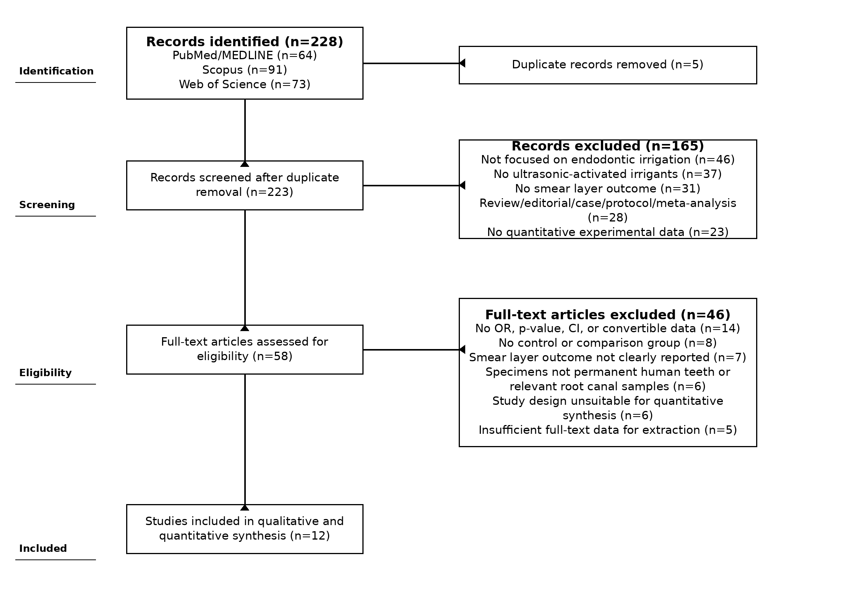
Figure 1. PRISMA flow diagram showing database identification, duplicate removal, screening, eligibility assessment, full-text exclusion reasons, and final inclusion of 12 studies.
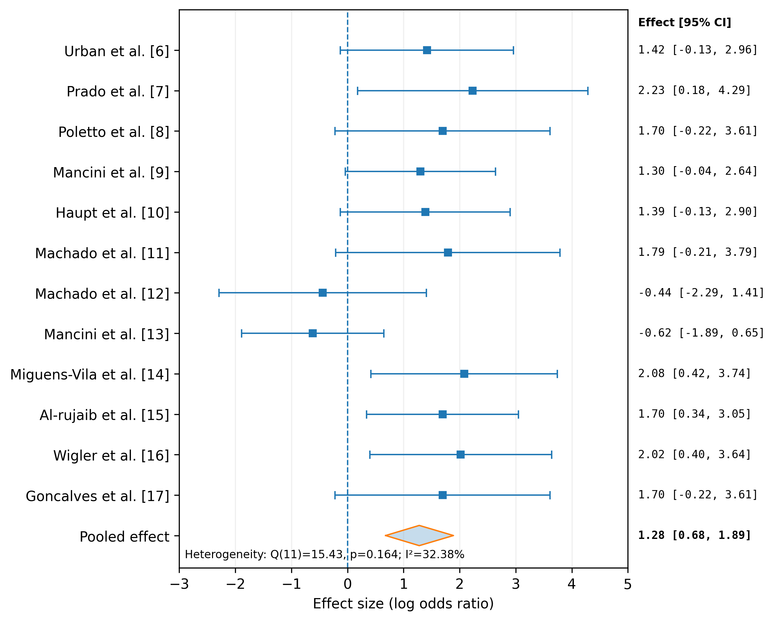
Figure 2. Forest plot of the effect of ultrasonic-activated irrigants on smear layer removal. The effect size is presented on the log odds ratio scale; values greater than zero favor ultrasonic-activated irrigation or the more effective activated protocol.
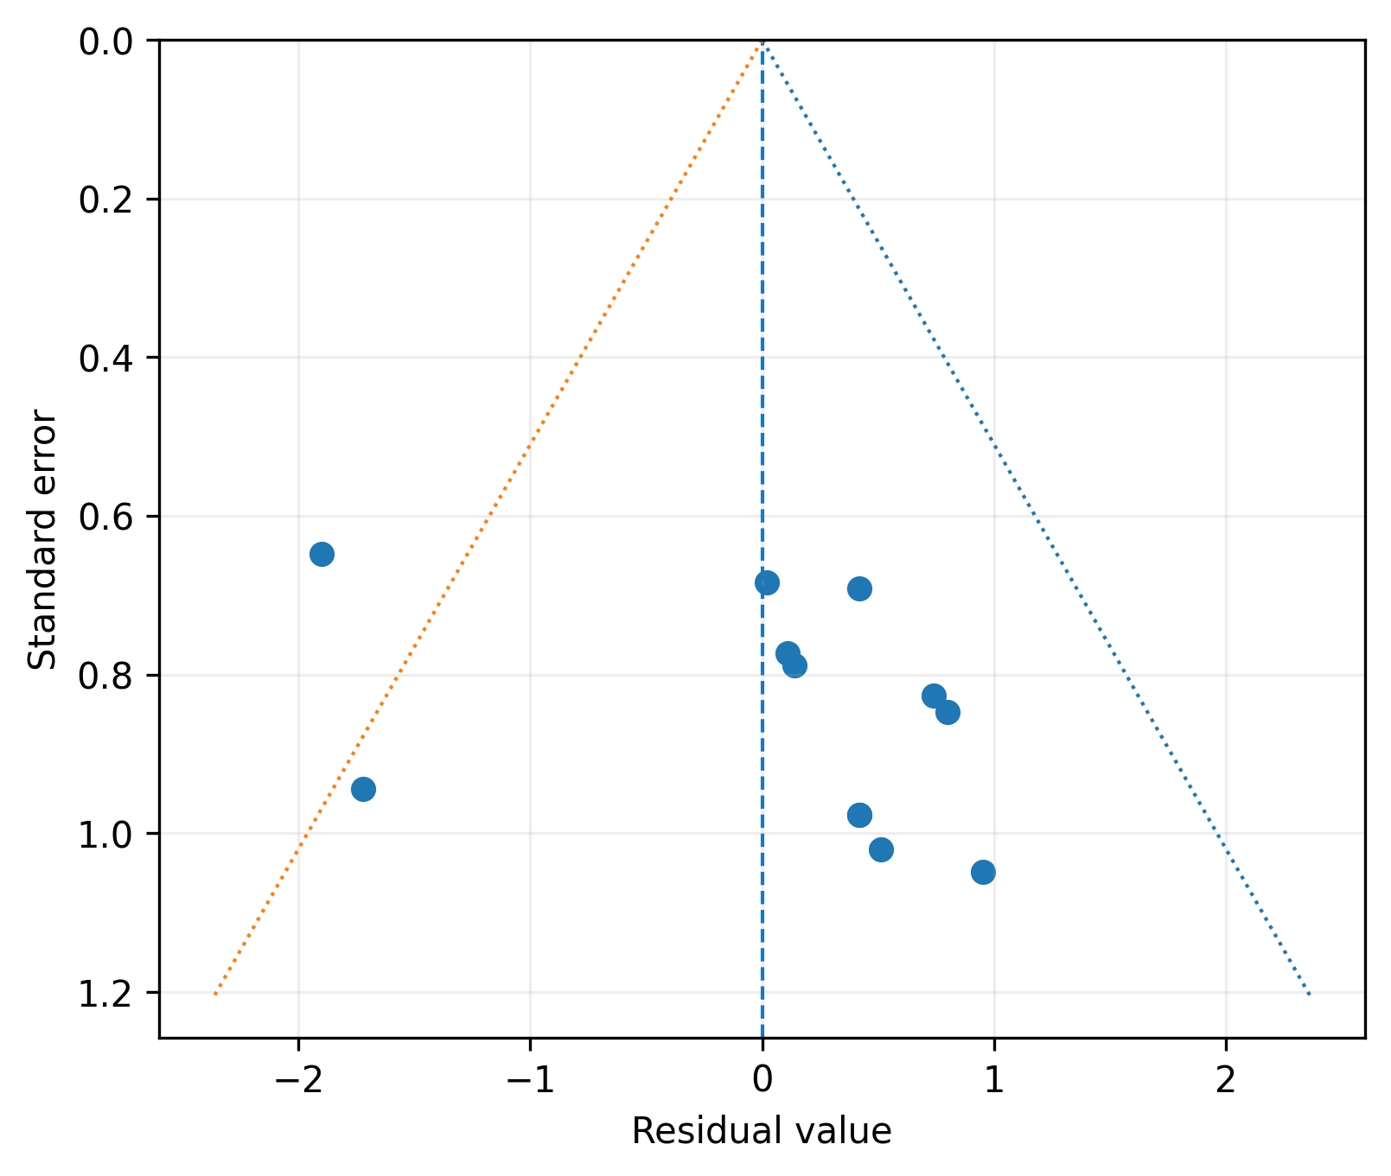
Figure 3. Funnel plot showing residual values and standard errors for the included studies. The asymmetric distribution suggests possible small-study effects or methodological variability.

